Thesis title

Name (Arial, bold, 16pt)
PhD (Arial, bold, 14pt)

Month Year (Arial, bold, 14pt)

Thesis title

Name
PhD

A thesis submitted in partial fulfilment of the University’s requirements for the Degree of Master of Philosophy (Arial, bold, italics, 14pt)

Month Year

Ethical approval

{Add ethical approval}

Acknowledgements

{Add Acknowledgements}

Contents
Contents
Ethical approval 3
Acknowledgements 4
Contents 5
List of Tables 7
List of Figures 7
Abstract 8
Chapter 1: 9
1.1. Introduction 9
1.1.1. Aim 9
1.2. Methods 9
1.2.1. Participant sample 9
1.2.2. Procedure 9
1.3. Results 9
1.3.1. Theme 1 10
1.3.2. Theme 2 10
Chapter 2: Use Styles 11
Headings – this is a heading without the Chapter in front 11
2.1. Using the Chapter headings then automatically creates the correct numbered subheadings 11
2.1.1. To change the format of a heading 11
Chapter 3: Creating a new section with a header 12
Chapter 3: Cross-references to tables and figures 14
Chapter 4: 15
References 15
Appendices 15
Appendices for Chapter 1: Appendix 1 16

Automatically update tables with Ctrl A (Select All) and then F9, select update entire table when window pops up, OR right click the table, update field and entire table.

List of Tables
Table 1: This is an example table 1

List of Figures
Figure 1: This is an example caption 1

Abstract
An abstract of up to one side of A4, which provides a synopsis of the thesis stating the nature and scope of the work undertaken and of the contribution made to the knowledge of the subject.

- Thesis Tip 1

Introduction
This is normal text for the thesis, font size should be no smaller than 10pt, clear and readable (e.g. Arial or Times New Roman). Text should be in one-and-a-half or double line spacing, except for indented quotations or footnotes where single spacing may be used.
This is an example quote using the heading style quote.
Pages should be numbered consecutively through the main text, including photographs and diagrams.

Aim

Methods
This is normal text

Participant sample

Procedure

Results
Table 1: This is an example table of final things to do for the thesis. In my draft thesis I included a table like this at the beginning of my document to keep track of any checks and edits to make.
Page | Still to do
Font cover | Add final title!
Title page | Add final title!
Ethical approval
Acknowledgements
Contents
List of Tables | Update F9
List of Figures | Update F9
Abstract | Check fits on one page
… Chapters*
Note. The table title is not APA format fully as the title would be underneath the table number
* Chapters were added separately from other documents when on final drafts

Figure 1: This is an example caption

Theme 1

Subtheme 1:

Theme 2

- Thesis Tip 2

Use Styles for headings –
this is a heading without the Chapter in front

Using the Chapter headings then automatically creates the correct numbered subheadings
On the Home tab go to Styles to change it to the appropriate level of heading
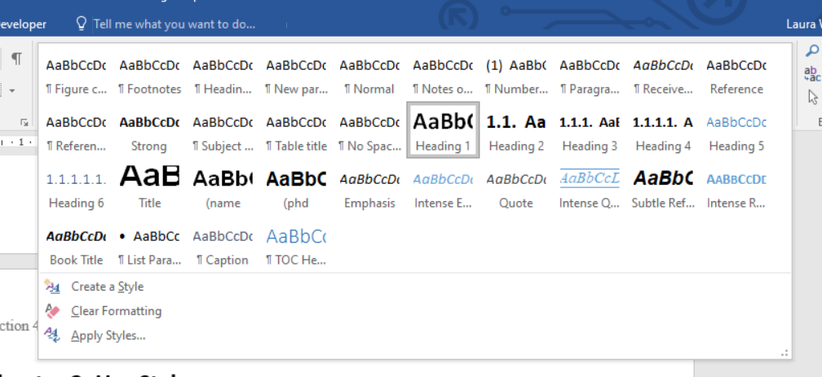
“You can also do this for quotes” (Wilde, 2023)
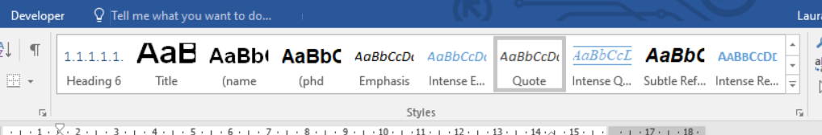

To change the format of a heading
Go to the heading and right click and Modify or highlight the text you want to use the formatting of and click update [style name] to match selection. This will automatically change all the headings with that style applied
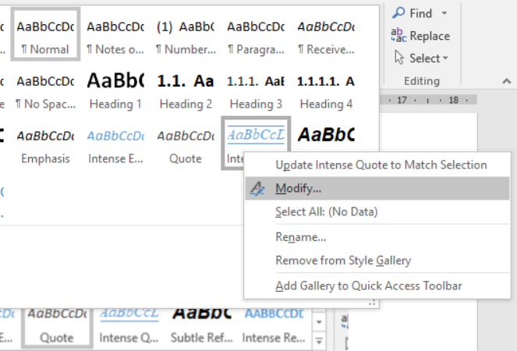

- Cross-reference to tables and figures
To add a cross reference within your text, such as to a Table or Figure, first create the captions for your items. Go to Reference and Insert Caption (Figure 4). Write a Caption for your title, select the kind of label it is and position (Figure 5).
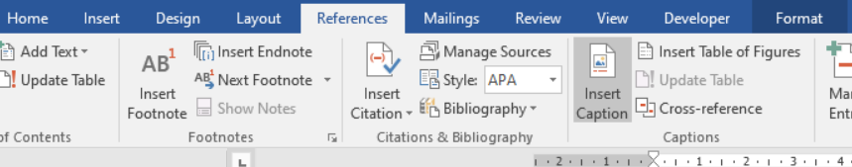
Figure 4: Create a caption with a title
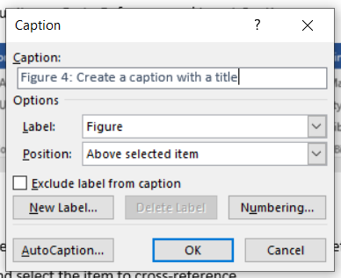
Figure 5: Write a caption
To reference these new wonderful captions, go to References> Cross-reference and select Reference Type (e.g. Table, Figure, Section etc.) and select the item to cross-reference.
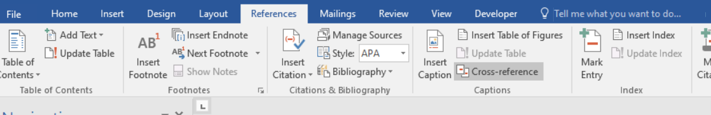
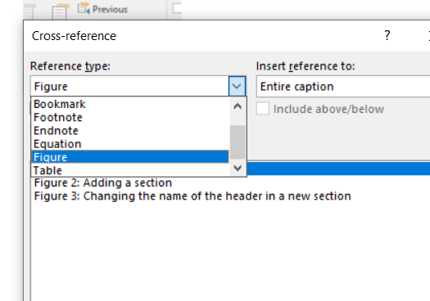

To update all your cross-references and contents tables: Ctrl A (Select All) and then F9 (on Windows).

- Creating a new section with a header
To add a new section – go to Layout>Breaks> Next Page (see Figure 2: Adding a section)
To change the header of the new section double click the header. To make it different to the previous section deselect Link to Previous (see Figure 3: Changing the name of the header in a new section)
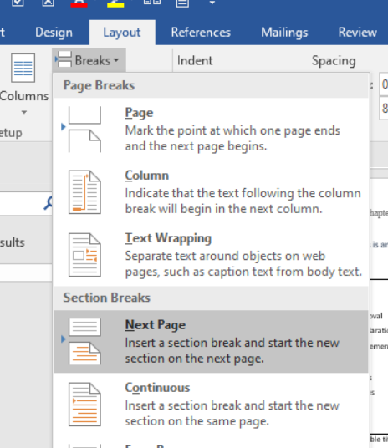
Figure 2: Adding a section

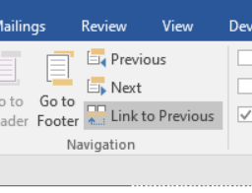
Figure 3: Changing the name of the header in a new section

Use Paragraph tools to change alignment and spacing really easily and neatly
E.g., To add a space to the line above so it is not directly below the line:
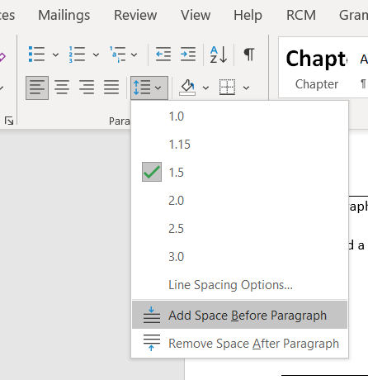

References
I used Endnote to manage my references and created an edited APA style.

Appendices
Add these last as it will make it will probably make the document massive. For now, just include headers so you can refer to your appendices as you are formatting. E.g., see Appendix 1.1 (1.1 is formatted to link to 1.1 below, you can do Ctrl and click 1.1 for it to take you to that location).
- Appendix 1
- Example Appendix Item

